**Load Testing from UI side**

**60 seconds, 167 users**

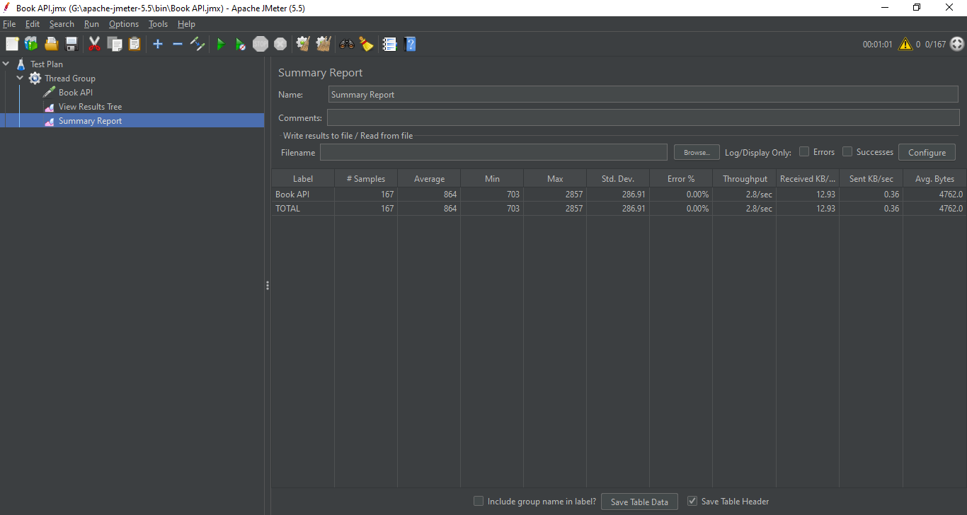

**300 seconds, 833 users**

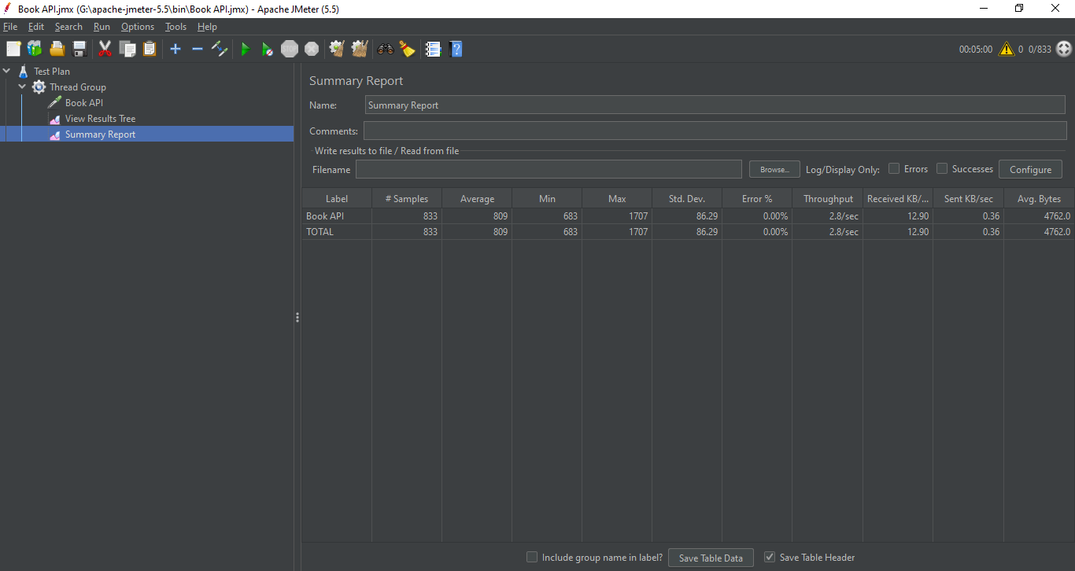

**600 seconds, 1667 users**

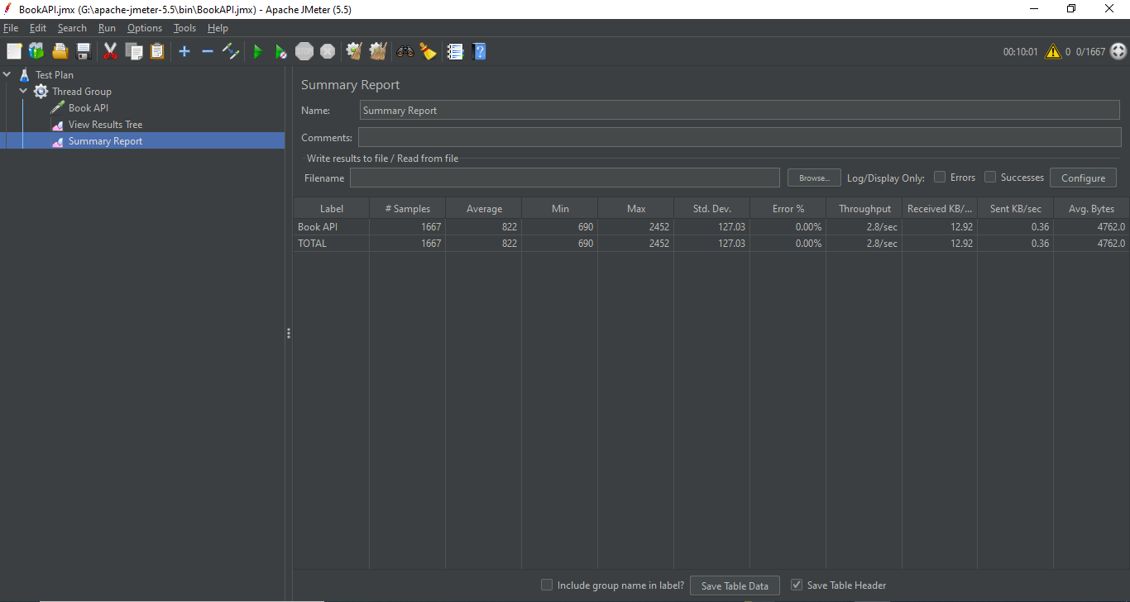

**Load Testing from command line**

**900 seconds, 2500 users**

